Eurasian National University named after L.N. Gumilyov

Faculty of «Information Technologies»

Department of «Information Systems»

**Labaratory work: 3**

**by discipline** «Development of client server IS»

**Student:** Iskakov Y.K.

**Group:** IS-35

**Checked by:** PhD. Akhmetova. A.Z.

**Laboratory work № 3. DEVELOPING TABLES AND CONSTRAINTS**

Option №.5 DB – Travel agency.

**Purpose of the laboratory work:** To learn how to create, modify, and delete tables. To gain skills in using the "SQL Server Management Studio" application to create, delete, and modify the structure of tables. To learn SQL operators for working with tables and indexes. To learn the types of constraints used in SQL Server. To gain skills in using the "SQL Server Management Studio" program to create, modify, and modify

**Tasks.**

1. **Create all database tables, keys, constraints and relationships.**

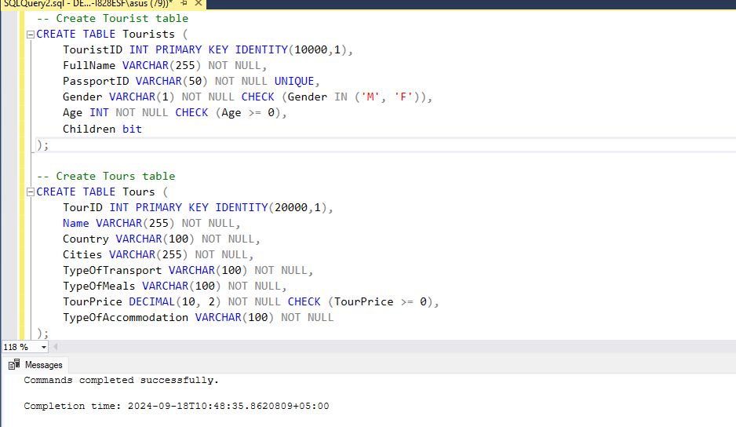

1. **Each table must have a primary key constraint.**
2. **Using foreign key constraints, all existing relationships between tables must be specified.**
3. **Depending on the conditions of the given task, additional integrity constraints may be imposed on columns in some tables or calculated fields must be developed.**
4. **Create a database diagram.**

1. **Fill the tables with data of at least 5 records in each.**

1. **Create a text report in which to display screenshots of the results of work in the SQL Server Management Studio DBMS (a window with a database with a list of all tables, table projects with a list of columns, windows of foreign key constraints (creation), a window with a list of keys for each table, windows with data for each table, a database diagram).**

**References**

Коды

-- Create Tourist table

CREATE TABLE Tourists (

TouristID INT PRIMARY KEY IDENTITY(10000,1),

FullName VARCHAR(255) NOT NULL,

PassportID VARCHAR(50) NOT NULL UNIQUE,

Gender VARCHAR(1) NOT NULL CHECK (Gender IN ('M', 'F')),

Age INT NOT NULL CHECK (Age >= 0),

Children bit

);

-- Create Tours table

CREATE TABLE Tours (

TourID INT PRIMARY KEY IDENTITY(20000,1),

Name VARCHAR(255) NOT NULL,

Country VARCHAR(100) NOT NULL,

Cities VARCHAR(255) NOT NULL,

TypeOfTransport VARCHAR(100) NOT NULL,

TypeOfMeals VARCHAR(100) NOT NULL,

TourPrice DECIMAL(10, 2) NOT NULL CHECK (TourPrice >= 0),

TypeOfAccommodation VARCHAR(100) NOT NULL

);

-- Create Tour Group table

CREATE TABLE TourGroup (

GroupID INT PRIMARY KEY IDENTITY(30000,1),

GroupName VARCHAR(255) NOT NULL,

DepartureDate DATE NOT NULL,

ArrivalDate DATE NOT NULL,

TourID INT NOT NULL,

NumberOfTourists INT NOT NULL CHECK (NumberOfTourists > 0),

FOREIGN KEY (TourID) REFERENCES Tours(TourID)

);

-- Create Group Composition table

CREATE TABLE GroupComposition (

GroupCompositionID INT PRIMARY KEY IDENTITY(40000,1),

SaleDate DATE NOT NULL,

TouristID INT NOT NULL,

GroupID INT NOT NULL,

TicketPrice DECIMAL(10, 2) NOT NULL CHECK (TicketPrice >= 0),

FOREIGN KEY (TouristID) REFERENCES Tourists(TouristID),

FOREIGN KEY (GroupID) REFERENCES TourGroup(GroupID)

);

-- Create Hotels table

CREATE TABLE Hotels (

HotelID INT PRIMARY KEY IDENTITY(50000,1),

HotelName VARCHAR(255) NOT NULL,

Country VARCHAR(100) NOT NULL,

City VARCHAR(100) NOT NULL,

Address VARCHAR(255) NOT NULL,

NumberOfRooms INT NOT NULL CHECK (NumberOfRooms > 0),

HotelType VARCHAR(100) NOT NULL

);

-- Create Sales Record table

CREATE TABLE SalesRecord (

SalesRecordID INT PRIMARY KEY IDENTITY(60000,1),

SaleDate DATE NOT NULL,

GroupID INT NOT NULL,

HotelID INT NOT NULL,

TotalCost DECIMAL(10, 2) NOT NULL CHECK (TotalCost >= 0),

FOREIGN KEY (GroupID) REFERENCES TourGroup(GroupID),

FOREIGN KEY (HotelID) REFERENCES Hotels(HotelID)

);

-- Tourists table

INSERT INTO Tourists (FullName, PassportID, Gender, Age, Children)

VALUES

('Alikhan Toktarov', 'KZ00123456', 'M', 30, 0),

('Mukhtar Ablyazov', 'KZ00123457', 'F', 28, 1),

('Yerassyl Iskakov', 'KZ00123458', 'M', 45, 0),

('Dana Nurzhigit', 'KZ00123459', 'F', 34, 0),

('Erlan Battashev', 'KZ00123460', 'M', 50, 2),

('Zhanar Lamasheva', 'KZ00123461', 'F', 40, 0),

('Kassym-Jomart Tokaev', 'KZ00123462', 'M', 27, 0);

-- Tours table

INSERT INTO Tours (Name, Country, Cities, TypeOfTransport, TypeOfMeals, TourPrice, TypeOfAccommodation)

VALUES

('Almaty Akkol', 'Kazakhstan', 'Almaty', 'Bus', 'Breakfast', 60000.00, 'Hotel'),

('Astana Alem', 'Kazakhstan', 'Astana', 'Train', 'Full Board', 75000.00, 'Hotel'),

('Shymkent Kultobe Trip', 'Kazakhstan', 'Shymkent', 'Plane', 'Breakfast', 32000.00, 'Guest House'),

('Baikonur Spaceport Tour', 'Kazakhstan', 'Baikonur', 'Bus', 'Half Board', 80000.00, 'Hotel'),

('Kazakhstan Culture', 'Kazakhstan', 'Almaty', 'Plane', 'Full Board', 30000.00, 'Resort'),

('Caspian Sea tour', 'Kazakhstan', 'Aktau', 'Plane', 'Full Board', 25000.00, 'Hotel'),

('Charyn Canyon Exploration', 'Kazakhstan', 'Almaty', 'Bus', 'Half Board', 38000.00, 'Guest House');

-- TourGroup table

INSERT INTO TourGroup (GroupName, DepartureDate, ArrivalDate, TourID, NumberOfTourists)

VALUES

('Group A', '2024-09-01', '2024-09-05', 20000, 6),

('Group B', '2024-09-10', '2024-09-15', 20001, 8),

('Group C', '2024-09-20', '2024-09-25', 20002, 2),

('Group D', '2024-10-01', '2024-10-05', 20003, 5),

('Group E', '2024-10-10', '2024-10-15', 20004, 5),

('Group F', '2024-10-20', '2024-10-25', 20005, 2),

('Group G', '2024-11-01', '2024-11-05', 20006, 4);

-- GroupComposition table

INSERT INTO GroupComposition (SaleDate, TouristID, GroupID, TicketPrice)

VALUES

('2024-08-01', 10000, 30000, 10000.00),

('2024-08-01', 10001, 30000, 10000.00),

('2024-08-05', 10002, 30001, 15000.00),

('2024-08-07', 10003, 30001, 15000.00),

('2024-08-10', 10004, 30002, 12000.00),

('2024-08-15', 10005, 30003, 20000.00),

('2024-08-18', 10006, 30004, 30000.00);

-- Hotels table

INSERT INTO Hotels (HotelName, Country, City, Address, NumberOfRooms, HotelType)

VALUES

('Kazakhstan Hotel', 'Kazakhstan', 'Almaty', 'Dostyk Ave, 52', 150, 'Hotel'),

('Astana Marriott Hotel', 'Kazakhstan', 'Astana', 'Dostyk St, 2', 120, 'Hotel'),

('Shymkent Plaza Hotel', 'Kazakhstan', 'Shymkent', 'Tauke Khan Ave, 7', 100, 'Hotel'),

('Baikonur Spaceport Hotel', 'Kazakhstan', 'Baikonur', 'Korolev St, 1', 80, 'Hotel'),

('Rixos Almaty', 'Kazakhstan', 'Almaty', 'Seifullin Ave, 506/99', 200, 'Resort'),

('Renaissance Aktau', 'Kazakhstan', 'Aktau', '1 Microdistrict, 2', 90, 'Hotel'),

('Charyn Guest House', 'Kazakhstan', 'Almaty', 'Zheltoksan St, 100', 50, 'Guest House');

-- SalesRecord table

INSERT INTO SalesRecord (SaleDate, GroupID, HotelID, TotalCost)

VALUES

('2024-08-01', 30000, 50000, 100000.00),

('2024-08-10', 30001, 50001, 120000.00),

('2024-08-20', 30002, 50002, 144000.00),

('2024-09-01', 30003, 50003, 200000.00),

('2024-09-10', 30004, 50004, 150000.00),

('2024-09-20', 30005, 50005, 175000.00),

('2024-10-01', 30006, 50006, 160000.00);